**Divisional income statement analysis  
  
1. Cleaning the data**

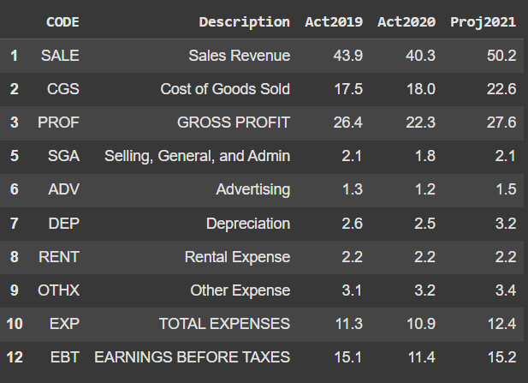

Division A

Division B

The data is now cleaned, the rows and columns with NaN values have been successfully removed leaving only the necessary data for visualization.

1. **A stacked bar chart of historical and projected sales over time that includes both divisions’ sales. The X-axis being the Year.**

X-axis: Represents the Year (e.g.,Actual 2019, Acutal 2020, Projected 2021)

Y-axis: Represents Sales Revenue or Sales Units

Analyzing the chart:

* In 2019, both divisions contributed evenly to overall sales, creating a balanced allocation.
* In 2020, both divisions' sales show a small drop. This could be due to a variety of circumstances, including market conditions, internal obstacles, or foreign economic effects.
* For expected sales (2021) A positive growth trend is foreseen, particularly in Division 2, where projected sales will increase to 45 units. Division 1 sales are expected to revert to the 2019 level.

1. **A clustered bar chart of sales overtime that includes both divisions’ sales. The X-axis being the Year.**

Key Insights:

* Both divisions' sales decreased from 2019 to 2020, possibly owing to market conditions or other external causes.
* The forecasted data for 2021 shows a recovery in both divisions, with Division 1 likely to exceed its 2019 sales and Division 2 expected to return to its 2019 level.
* Division 1 consistently outperformed Division 2 in all years.

1. **Two separate pie charts, one for each division, showing the different kinds of expenses forecasted for 2021.**

* Division 2 allocates a much higher percentage (32.1%) to Advertising than Division 1 (12.1%), reflecting a heavy emphasis on marketing and promotion. This could be a purposeful strategy to raise brand awareness or boost sales growth.
* Division 1 as a high allocation of 27.4% to other expenses, suggesting a broad range of miscellaneous or unforeseen costs.
* Division1 a larger allocation of 25.8% to depreciation, indicating significant investments in assets that depreciate over time.
* Division 2 allocates 15.0% for Selling, General, and Administration, which is a little less than Division 1. This could indicate disparities in organizational structure or administrative efficiency.